PUBLIC RESPONSIBILITY AND INEQUALITY IN HEALTH INSURANCE COVERAGE: AN EXAMINATION OF AMERICAN STATE HEALTH CARE SYSTEMS

STATISTICAL APPENDIX

Ling Zhu and Morgen Johansen

OVERVIEW
In this Statistical Appendix, we present descriptive statistics about the original Current Population Survey’s Annual Social and Economic Supplement (CPS-ASEC) data used to compute the dependent variable—the weighted Gini-coefficient index of relative inequality, and descriptive statistics for all variables. We also present information on the data sources for all of our independent variables, and discuss the results of various robustness checks concerning our choices about possible endogenous relationships and multicollinearity.

1. CPS-ASEC Samples from 2002 to 2010
Table 1 in this Appendix reports details on the CPS-ASEC sample by state by year. The CPS-ASEC is a nationally representative household survey with a very large sample-size (approximately 17,000+ households). ASCE asks a variety of questions regarding the respondents’ socio-economic situations. Raw data are obtained from the U.S. Census Bureau data link: http://www.census.gov/cps/data/cpstablecreator.html. We use the question on health insurance coverage to examine the relative inequality across nine income groups. Specifically, the health insurance coverage question in CPS-ASEC asks individuals if they were covered by any health insurance plan in the past 12 months. Hence, our inequality measure does not capture the small proportion of the population who are uninsured only temporarily. As Table 1 shows, the state-level samples are very stable across time and the total sample size in each year is very large, which ensures a reliable estimation of the uninsured rate across income-groups.

[Table 1 About Here]

2. Computing the Gini-Coefficient Measure of Relative Inequality
To compute the Gini-coefficient measure of relative inequality, we use data from the CPS-ASEC from 2002 to 2010. A weighted Gini-index measure is computed based on the CPS-ASEC sample size of each income group in all state/year tabulations and the state-level consumer price index (CPI). The state CPI data are obtained from William Berry’s research website: http://mailer.fsu.edu/~wberry/garnet-wberry/a.html. See Berry, Fording and Hanson (2000) for the theoretical discussion about the state-level CPI measure. (Berry, W. D., Fording, R.C., & Hanson, R.L. 1998. “An annual cost of living index for the American states, 1960-95.” Journal of Politics, 62, 550-67.)

As Table 2 demonstrates, in the theoretical scenario of perfect equality, the rate of health insurance coverage should be identical across all income groups. The perfect equality scenario is also shown as the 45-degree diagonal lines in Figure 1.
Figure 1 presents the Lorenz-Curve scenarios corresponding to the minimum, maximum, and mean of the inequality index in the sample. In a theoretical scenario of perfect equality, the rate of health insurance coverage should be identical across all income groups. This scenario is represented by the 45-degree diagonal lines in Figure 1, and the curves sitting below the diagonal line indicate that the lack of health insurance coverage is more concentrated among the poor. Figure 1 shows that West Virginia in 2002 provided more equal coverage than Maryland in 2002 and Massachusetts in 2005.

[Figure 1 About Here]
[Table 2 About Here]

2. Summary Statistics of the Dependent and Independent Variables
Table 3 and Figure 2 provide summary statistics for the dependent variable. As Table 3 and Figure 2 show, the mean inequality values are fairly stable across different years. The cross-state ranges, however, change from year to year. Looking at the inequality trend across years in each state, this inequality measure captures both cross-state variations and cross-time variations. For example, the level of inequality is persistently high in the state of Texas. Both Hawaii and Massachusetts rigidly enforce mandated employment-based health insurance, and as expected, the inequality scores are much lower in these two states than in Texas. Massachusetts witnessed a sharp decrease in its inequality score after 2006, when its new health insurance law was enacted. On the other hand, many states experienced a sharp increase in their inequality scores in 2010. Nearly all of these states (e.g. CA, MA, NH, NJ, NV, NY and RI) had very high unemployment rates in 2010. For example, in 2010, the unemployment rates in CA, NJ, NV and RI were 12.2%, 9.5%, 14.9% and 11.6%, respectively.

[Table 3 About Here]
[Figure 2 About Here]

Table 4 provides summary statistics for all of the independent variables. The data sources for the variables are as follows:

Ownership: Data for computing the ownership measure are drawn from the American
Hospital Association (AHA) Annual Hospital Directory, which provides the most comprehensive hospital directory of more than 5,000 health care organizations. The measure of ownership publicness captures all service types including general hospitals, children’s hospitals, psychiatric centers, cancer centers, acute long-term care facilities, rehabilitation facilities, mental health institutions, and care units owned by universities and prisons.

Financial Publicness: Data for this measure are drawn from the U.S. Department of Health and Human Services, Centers for Medicaid and Medicare Services Expenditure Reports.

Political control: Data for this variable are drawn from the Kaiser Family Foundation’s policy report on state Medicaid eligibility rules (Heberlein, M., Brooks, T., Guyer, J., Artiga, S., & Stephens, J. 2011. Holding steady, looking ahead: Annual findings of a 50-state survey of eligibility rules, enrollment and renewal procedures, and cost sharing practices in Medicaid and CHIP, 2010-2011. The Henry J. Kaiser Family Foundation, Commission on Medicaid and Uninsured. Available at: http://www.kff.org/medicaid/8130.cfm. Accessed May 2011.)

Health risk factors: Data for these three variables are drawn from the Centers for Disease Control Behavioral Risk Factor Surveillance System.

Unemployment is measured with the annual state level unemployment rates, and income is measured by per capita disposable income in 2005 constant dollars.

[Table 4 About Here]

Table 5 reports bivariate Pearson correlations of the four publicness measures: ownership, finance, and control (eligibility and legislation). As Table 5 shows, the four measures are related but different dimensions of health care publicness.

[Table 5 About Here]

3. Potential Endogenous Relationships
Potentially, there may be endogenous relationships between dimensions of publicness and social inequality in health insurance coverage. For example, states may increase the proportion of public health care spending if the level of inequality is higher. States may exert more public control over the health care system because the level of social inequality is high. If these endogenous relationships exist, the measure for social inequality should significantly predict dimensions of publicness. Setting the publicness variables as dependent variables, we check if the Gini-index of inequality predicts our measures of publicness. Table 6 reports the full set of the endogeneity checks. In all of the models, we set one publicness measure as the dependent variable, include the inequality measure as a key explanatory variable and control for the full set of social, economic, and political variables used in our reported model.

Panel models are first estimated based on the fixed-effects specification. Because fixed-effects (FE) models only capture the within-state mean effects, and some of the publicness measures such as ownership and control do not change substantially across the nine years, the FE will artificially produce insignificant coefficients by “throwing out” cross-states variations. Therefore, we also run the same check based on the random-effects (RE) specification. To rule out potential endogenous relationships, we want to compare across two specifications (FE and RE) for coherent evidence that the inequality variable does not significantly predict the publicness measures. As Table 6 shows, none of the coefficients associated with the inequality variable are significant. We do not find evidence of endogenous relationships.

[Table 6 About Here]

4. Multicollinearity
Since many of the socio-economic variables in our model are based on population percentages, there could be relatively high collinearity among these variables. We estimate the Variance Inflation Factor (VIF) statistics to check if the population percentage measures have troublesome VIF statistics. None of the publicness variables are associated with a troublesome VIF value, but the socio-economic variables are with high un-centered VIF statistics (see Table 7). To make sure that multicollinearity does not affect the results pertaining to our key publicness variables, we check the robustness of model results for the main interaction model (reported as Table 1, Model (3) in the manuscript) by mean-centering all the population percentage measures. Findings for the four publicness variables do not change with or without the mean-centering variables (see Table 8).

[Table 7 About Here]
[Table 8 About Here]

5. Testing Hypotheses 4a and 4b with the Second Measure for Public Control
In addition to the interaction models reported in the manuscript, we test hypotheses H4a and 4b based on the second public control measure (state legislation). Table 9 presents results of the additional interaction models. Model (1) includes an interaction term between the public ownership measure and the second measure for public control (i.e. legislative mandates). The interaction term has a small coefficient size and is statistically insignificant. Thus, Model (1) does not support H4a. Model (2) tests H4b by including an interaction term between the public financing measure and the measure for legislative mandates. Similarly, the model yields an insignificant interaction term. In sum, the two additional interaction models do not provide evidence that state health care mandates condition the effect of public ownership and public financing. For brevity, we only present the additional interaction models in this statistical appendix.

[Table 9 About Here]

6. Robustness Analysis: Models Estimated by Clustering Standard Errors by States
In the manuscript, we estimate panel models using panel-corrected standard errors (PCSEs). To check the robustness of this model specification, we re-estimate the three models by clustering standard errors by states. Table 10 reports results for the three models with robust clustered standard errors. The three models in Table 10 yield slightly greater standard error estimates than those reported in the manuscript (i.e., using PCSEs). The two sets of standard error estimates, nevertheless, are comparable. We also reach the same conclusion about testing H1-4 based on Table 10. Thus, the results reported in the manuscript are robust.

[Table 10 About Here]

7. The Non-Linear Effects of Income and Education on Inequality
In the manuscript, we include per capita income and population education attainment (% college degree) as two control variables. To check the non-linear effects of income and education on inequality, we re-estimate the model (Model (3) in Table 1 in the manuscript) by adding two quadratic terms: income-squared and education-squared. Table 11 shows that both squared terms are statistically significant. Nevertheless, the coefficients of the two squared terms are quite small compared with the coefficients of the two linear terms for income and education. This indicates that the non-linear effects are statistically significant, but substantively small.

[Table 11 About Here]

In Figure 3, we further evaluate the non-linear relationship between income and inequality by comparing the quadratic predictions with the linear predictions, using income as the key predictor of inequality. As Figure 3 shows, the 95% confidence intervals of the linear and quadratic predictions overlap across the full range of the income variable. Figure 4 compares the linear and quadratic relationships between education and inequality, using education as the key predictor of inequality. Although the non-linearity in Figure 4 is more noticeable than in Figure 3, the 95% confidence intervals of the linear and quadratic predictions also overlap across the full range of the education variable. Because adding the two quadratic terms does not lead to statistically different predictions of the inequality index, we chose to report the models with only the linear terms for the two control variables. In this way, we keep our model specification more parsimonious.

[Figure 3 About Here]
[Figure 4 About Here]

TABLES

Table 1. CPS-ASEC Sample Size by State and Year
State | 2002 | 2003 | 2004 | 2005 | 2006 | 2007 | 2008 | 2009 | 2010
AL | 4440 | 4427 | 4512 | 4524 | 4532 | 4570 | 4720 | 4669 | 4672
AK | 635 | 645 | 649 | 659 | 659 | 675 | 673 | 691 | 693
AZ | 5442 | 5576 | 5768 | 6047 | 6269 | 6368 | 6537 | 6513 | 6703
AR | 2692 | 2671 | 2731 | 2760 | 2758 | 2805 | 2827 | 2852 | 2880
CA | 35159 | 35394 | 35854 | 35940 | 36208 | 36295 | 36691 | 36794 | 37223
CO | 4477 | 4480 | 4524 | 4641 | 4803 | 4877 | 4916 | 4971 | 5050
CT | 3382 | 3421 | 3492 | 3487 | 3462 | 3476 | 3437 | 3480 | 3497
DE | 798 | 820 | 826 | 844 | 862 | 863 | 863 | 884 | 881
FL | 16429 | 16921 | 17468 | 17886 | 18062 | 18074 | 18049 | 18405 | 18531
GA | 8426 | 8571 | 8706 | 9045 | 9347 | 9493 | 9553 | 9671 | 9832
HI | 1224 | 1253 | 1249 | 1279 | 1255 | 1267 | 1258 | 1251 | 1257
ID | 1300 | 1360 | 1375 | 1442 | 1475 | 1501 | 1518 | 1526 | 1531
IL | 12504 | 12628 | 12592 | 12608 | 12644 | 12688 | 12703 | 12767 | 12901
IN | 6100 | 6149 | 6136 | 6141 | 6337 | 6263 | 6295 | 6364 | 6359
IA | 2903 | 2921 | 2906 | 2909 | 2919 | 2970 | 2990 | 2995 | 2962
KS | 2685 | 2683 | 2674 | 2695 | 2723 | 2722 | 2724 | 2745 | 2757
KY | 4046 | 4110 | 4074 | 4052 | 4106 | 4207 | 4256 | 4282 | 4292
LA | 4447 | 4429 | 4421 | 4088 | 4212 | 4197 | 4335 | 4453 | 4432
ME | 1269 | 1283 | 1294 | 1320 | 1315 | 1313 | 1319 | 1300 | 1285
MD | 5458 | 5493 | 5550 | 5569 | 5613 | 5565 | 5539 | 5667 | 5727
MA | 6470 | 6367 | 6370 | 6328 | 6335 | 6340 | 6421 | 6631 | 6616
MI | 9910 | 9918 | 9974 | 9982 | 9970 | 9927 | 9816 | 9815 | 9772
MN | 5054 | 5076 | 5127 | 5129 | 5149 | 5190 | 5121 | 5203 | 5186
MS | 2787 | 2854 | 2868 | 2854 | 2892 | 2903 | 2907 | 2850 | 2929
MO | 5585 | 5623 | 5614 | 5710 | 5800 | 5791 | 5871 | 5969 | 5979
MT | 906 | 917 | 912 | 928 | 931 | 939 | 976 | 972 | 971
NE | 1704 | 1727 | 1729 | 1766 | 1767 | 1753 | 1776 | 1780 | 1788
NV | 2121 | 2250 | 2392 | 2448 | 2535 | 2568 | 2584 | 2632 | 2639
NH | 1266 | 1264 | 1293 | 1301 | 1309 | 1314 | 1301 | 1314 | 1302
NJ | 8604 | 8579 | 8662 | 8725 | 8660 | 8556 | 8524 | 8680 | 8672
NM | 1840 | 1871 | 1902 | 1938 | 1943 | 1946 | 1978 | 1978 | 2015
NY | 19283 | 18970 | 19054 | 19022 | 19040 | 19062 | 19338 | 19184 | 19289
NC | 8162 | 8253 | 8435 | 8561 | 8851 | 9183 | 9253 | 9348 | 9248
ND | 633 | 631 | 627 | 626 | 617 | 615 | 627 | 632 | 635
OH | 11282 | 11247 | 11270 | 11334 | 11319 | 11300 | 11397 | 11462 | 11349
OK | 3477 | 3438 | 3444 | 3505 | 3492 | 3551 | 3558 | 3636 | 3673
OR | 3510 | 3569 | 3582 | 3627 | 3715 | 3762 | 3815 | 3835 | 3777
PA | 12190 | 12155 | 12175 | 12281 | 12345 | 12313 | 12195 | 12414 | 12453
RI | 1056 | 1053 | 1056 | 1054 | 1054 | 1044 | 1044 | 1033 | 1048
SC | 3997 | 4064 | 4124 | 4181 | 4226 | 4384 | 4470 | 4507 | 4526
SD | 745 | 751 | 754 | 768 | 770 | 788 | 798 | 800 | 806
TN | 5672 | 5909 | 5857 | 5867 | 5920 | 6150 | 6183 | 6253 | 6311
TX | 21529 | 21858 | 22331 | 22819 | 23236 | 23704 | 24194 | 24657 | 25154
UT | 2310 | 2352 | 2393 | 2524 | 2537 | 2657 | 2759 | 2800 | 2829
VT | 619 | 611 | 617 | 622 | 620 | 614 | 612 | 618 | 622
VA | 7118 | 7386 | 7383 | 7454 | 7538 | 7684 | 7748 | 7778 | 7771
WA | 6001 | 6091 | 6118 | 6250 | 6318 | 6509 | 6540 | 6714 | 6723
WV | 1751 | 1787 | 1792 | 1799 | 1814 | 1795 | 1799 | 1805 | 1807
WI | 5475 | 5429 | 5463 | 5447 | 5476 | 5473 | 5555 | 5565 | 5610
WY | 488 | 488 | 498 | 511 | 516 | 518 | 530 | 541 | 537
Total | 285933 | 288277 | 291164 | 293837 | 296825 | 299104 | 301485 | 304282 | 306110

Table 2. Understanding the Gini-Index of Inequality: Income-Based Health Insurance Coverage in West Virginia 2002, Maryland 2002, and Massachusetts 2005, Current Population Survey-Annual Social Economic Supplement 2002 and 2005
State /Year | $0 | $1-  4,999 | $5,000-9,999 | $10,000-  $14,999 | $15,000-24,999 | $25,000-  34,999 | $35,000-44,999 | $50,000-74,999 | $75,000+ | Overall Insured | Gini-  Index
West Virginia 2002 (Sample Min Value)
Insured | 18 | 33 | 113 | 121 | 221 | 214 | 241 | 278 | 271 | 86.23% | 0.208
Sample Size | 30 | 41 | 141 | 153 | 275 | 245 | 271 | 391 | 294
Massachusetts 2005 (Sample Mean Value)
Insured | 72 | 101 | 186 | 236 | 507 | 415 | 610 | 993 | 2662 | 91.37% | 0.326
Sample Size | 112 | 116 | 202 | 282 | 606 | 479 | 694 | 1086 | 2751
Maryland 2002 (Sample Max Value)
Insured | 46 | 53 | 147 | 180 | 278 | 426 | 593 | 917 | 2178 | 88.27% | 0.437
Sample Size | 97 | 75 | 189 | 230 | 351 | 520 | 723 | 992 | 2281
A Theoretical Scenario of Perfect Equality
Insured | 112 | 116 | 202 | 282 | 606 | 479 | 694 | 1086 | 2751 | 100% | 0
Sample Size | 112 | 116 | 202 | 282 | 606 | 479 | 694 | 1086 | 2751
Notes:
- The Gini-index scores are weighted by CPS sample size for each income group in a given state/year.
- The overall uninsured rate is calculated based on the CPS sample.
- The theoretical scenario of perfect equality is constructed based on the CPS sample of MA 2005.

Table 3. Summary Statistics of the Weighted Gini-Index of Relative Inequality by Year
Year | N | Mean | Sd. | Min | Max
2002 | 50 | 0.322 | 0.043 | 0.208 | 0.437
2003 | 50 | 0.326 | 0.041 | 0.228 | 0.412
2004 | 50 | 0.329 | 0.030 | 0.274 | 0.405
2005 | 50 | 0.325 | 0.031 | 0.240 | 0.403
2006 | 50 | 0.326 | 0.028 | 0.259 | 0.403
2007 | 50 | 0.329 | 0.028 | 0.258 | 0.407
2008 | 50 | 0.322 | 0.026 | 0.259 | 0.381
2009 | 50 | 0.319 | 0.030 | 0.254 | 0.392
2010 | 50 | 0.338 | 0.035 | 0.253 | 0.397

Table 4. Summary Statistics of All Variables
Variable | Mean | Standard Deviation | Min | Max
Gini Index of Inequality | 0.326 | 0.033 | 0.208 | 0.437
Ownership | 21.664 | 17.040 | 0 | 70.830
Financing | 32.636 | 5.230 | 24.030 | 40.740
Control (Eligibility) | 86.776 | 57.815 | 17 | 275
Control (Legislation) | 0.293 | 0.854 | 0 | 8
Overall Uninsured Rate | 13.690 | 3.871 | 4.300 | 25.500
Unemployment | 5.787 | 2.050 | 2.500 | 24.900
Per Capita Income (in ,000) | 32.641 | 3.195 | 25.500 | 45.970
College Degree | 40.659 | 4.425 | 28.160 | 51.150
Racial Diversity | 0.378 | 1.578 | 0.062 | 0.785
Poor Health Status | 3.502 | 1.352 | 1.310 | 8.300
Smoking Rate | 20.486 | 3.655 | 9.100 | 32.600
Obesity Rate | 25.037 | 3.610 | 16.000 | 35.400
Aged Population | 12.435 | 1.806 | 5.860 | 17.260
State Ideology (Liberal to Conservative) | 0.058 | 0.290 | -0.578 | 0.523

Table 5. Pearson Correlations among the Four Publicness Measures: Ownership, Finance, and Control (p-values in parentheses)

 | Ownership | Finance | Control (Eligibility) | Control (Legislation)
Ownership | 1.0000
Finance | -0.0062  (0.8961) | 1.0000
Control (Eligibility) | -0.3698  (0.0000) | 0.0047  (0.9216) | 1.0000
Control (Legislation) | -0.0828  (0.0792) | 0.0630  (0.1824) | 0.0568  (0.2292) | 1.0000

Table 6. Checking for Potential Endogenous Relationships
Dependent Variable | Ownership  Coefficient  Fixed Effects | Ownership  Coefficient  Random Effects | Δ Financing Coefficient  Fixed Effects | Δ Financing  Coefficient  Random Effects | Eligibility Coefficient  Fixed Effects | Eligibility  Coefficient  Random Effects
Gini Index of Inequality | -7.2841(7.1323) | -8.1279(7.0083) | -2.0457(2.6760) | 0.0517(1.4715) | -1.3458(0.7507) | -0.8514(0.7739)
Overall Uninsured Rate | -0.0854(0.1116) | -0.0669(0.1101) | 0.0364(0.0364) | 0.0330(0.0118) | -0.4055(0.8405) | -1.1095(0.8155)
Unemployment | -0.0008(0.0917) | 0.0043(0.0920) | 0.0685(0.0243) | 0.0585(0.0164) | 0.2971(1.1406) | 0.2957(1.1574)
Per Capita Income | 0.6073*(0.1624) | 0.6217*(0.1601) | -0.0115(0.0285) | 0.0053(0.0127) | 2.4592*(1.1304) | 1.4244(0.8506)
College Degree | 0.0529(0.1337) | 0.0470(0.1351) | -0.0027(0.0379) | -0.0163(0.0158) | 1.0098(1.1422) | 1.2533(1.2058)
Racial Diversity | 12.5083(10.7077) | 10.7982(9.1118) | 3.1029(1.4862) | -0.3864(0.3751) | 1.3196(0.8530) | 0.4443(0.4556)
Poor Health | -0.0910(0.2562) | -0.0536(0.2566) | -0.0356(0.0944) | -0.0465(0.0438) | 1.6950(2.1872) | 0.2199(1.9257)
Smoking Rate | 0.1311(0.1506) | 0.1586(0.1451) | -0.0702(0.0457) | -0.0268(0.0119) | -0.1722(0.8156) | -0.9897(0.8786)
Obesity Rate | -0.2796*(0.1187) | -0.2492*(0.1116) | 0.0064(0.3510) | 0.0512(0.0180) | -0.6268(0.9162) | -1.6606*(0.7972)
State Ideology | -0.4556(1.3152) | -0.1923(1.2729) | -0.9072(0.5783) | -0.2604(0.2357) | 8.0385(13.8130) | 10.3575(12.0748)
Aged Population | -0.1503(0.1627) | -0.1670(0.1634) | -0.0758(0.0492) | 0.0267(0.0227) | -0.1900(1.1548) | -0.2763(1.1780)
N | 450 | 450 | 450 | 450 | 450 | 450
Within R² | 0.2304 | 0.2297 | 0.1161 | 0.0935 | 0.0318 | 0.0156
Between R² | 0.0050 | 0.0022 | 0.0000 | 0.1671 | 0.0165 | 0.2784
Notes:
- Significance levels: ** p<.05, two-tailed test.
- Robust standard errors are estimated adjusting for 50 clusters (i.e. states) and reported in parentheses.
- The Anti-ACA dummy is omitted if a model is estimated based on the fixed-effects specification. Intercepts are not reported.

Table 7. Variance Inflation Factor (VIF) Statistics for Key Variables
Variables | VIF  (Centered) | VIF  (Un-centered)
College Degree | 3.24 | 277.60
Poor Health | 3.15 | 149.99
Smoking | 2.64 | 85.71
State Ideology | 2.38 | 2.48
Overall Uninsured Rate | 2.34 | 31.74
Racial Diversity | 2.21 | 14.95
Obesity | 2.09 | 102.63
Public Control (Eligibility) | 1.89 | 6.16
Per Capita Income | 1.45 | 149.99
Unemployment | 1.42 | 13.07
Aged Population | 1.39 | 67.39
Public Ownership | 1.31 | 3.44
Public Control (Legislation) | 1.20 | 1.46
Public Finance | 1.11 | 1.43

Table 8. Model (1) in Table 1, Estimated Including Mean-Centered Control Variables
Variable | Model 1  Coefficient | PCSEs
Ownership | -0.0009** | 0.0004
Financing | 0.0027 | 0.0018
Control (Eligibility) | -0.00009** | 0.00004
Financing × Eligibility | -0.00004** | 0.00001
Control (Legislation) | -0.0012 | 0.0010
Overall Uninsured Rate | 0.0015** | 0.0008
Unemployment | 0.0034** | 0.0010
Per Capita Income | 0.0086** | 0.0007
College Degree | 0.0030** | 0.0008
Racial Diversity | -0.0997 | 0.0644
Poor Health | 0.0023 | 0.0018
Smoking Rate | 0.0032** | 0.0009
Obesity Rate | 0.0022** | 0.0008
State Ideology | -0.0193** | 0.0080
Aged Population | -0.0012 | 0.0012
N | 450
R² | 0.7545
Significance levels: * p<.10, ** p<.05, two-tailed test.

Table 9. Additional Interaction Models
 | Model (1) | Model (2)
Variable | Coefficient  (PCSEs) | Coefficient  (PCSEs)
Ownership | -0.0009**  (0.0004) | -0.0010**  (0.0004)
Financing | -0.0007  (0.0011) | -0.0015  (0.0011)
Control (Eligibility) | -0.0001**  (0.00004) | -0.0001**  (0.00004)
Control (Legislation) | -0.0050*  (0.0020) | -0.0029*  (0.0016)
Ownership × Legislation | 0.0002  (0.0006) | --
Financing ×Legislation | -- | 0.0032  (0.0021)
Overall Uninsured Rate | 0.0035**  (0.0008) | 0.0017**  (0.0007)
Unemployment | 0.0035**  (0.0010) | 0.0036**  (0.0010)
Per Capita Income | 0.0085**  (0.0008) | 0.0087**  (0.0007)
College Degree | 0.0032**  (0.0008) | 0.0032**  (0.0008)
Racial Diversity | -0.0874  (0.0650) | -0.1094*  (0.0638)
Poor Health Status | 0.0020  (0.0019) | 0.0023  (0.0018)
Smoking Rate | 0.0034**  (0.0009) | 0.0032**  (0.0009)
Obesity Rate | 0.0020**  (0.0008) | 0.0022**  (0.0008)
State Ideology | 0.0282**  (0.0083) | 0.0189**  (0.0079)
Aged Population | -0.0009  (0.0012) | -0.0013  (0.0012)
N | 450 | 450
R² | 0.754 | 0.758
Significance levels: * p<.10, ** p<.05, two-tailed test.

Table 10. Alternative Model Specification: Clustering Standard Errors by States
 | Model (1) | Model (2) | Model (3)
Variable | Coefficient  (PCSEs) | Coefficient  (PCSEs) | Coefficient  (PCSEs)
Ownership | -0.0010*  (0.0005) | -0.0012**  (0.0006) | -0.0010*  (0.0005)
Financing | -0.0009  (0.0011) | -0.0009  (0.0012) | 0.0028  (0.0018)
Control (Eligibility) | -0.0001*  (0.00006) | -0.0002*  (0.0001) | -0.00009*  (0.00005)
Ownership × Eligibility | -- | 3.11e-06  (4.16e-06 ) | --
Financing ×Eligibility | -- | -- | -0.0004**  (0.00002)
Control (Legislation) | -0.0010  (0.0015) | -0.0011  (0.0015) | -0.0012  (0.0015)
Overall Uninsured Rate | 0.0015  (0.001) | 0.0015  (0.0014) | 0.0015  (0.0014)
Unemployment | 0.0033**  (0.0015) | 0.0032**  (0.0015) | 0.0034**  (0.0015)
Per Capita Income | 0.0086**  (0.0009) | 0.0084**  (0.0007) | 0.0086**  (0.0008)
College Degree | 0.0028**  (0.001) | 0.0027**  (0.0011) | 0.0030**  (0.0010)
Racial Diversity | -0.0978  (0.0611) | -0.0933  (0.0615) | -0.1000*  (0.0595)
Poor Health Status | 0.0019  (0.0022) | 0.0020  (0.0023) | 0.0023  (0.0022)
Smoking Rate | 0.0033**  (0.0013) | 0.0032**  (0.0013) | 0.0032**  (0.0014)
Obesity Rate | 0.0021*  (0.0011) | 0.0021*  (0.0012) | 0.0022*  (0.0011)
State Ideology | 0.0224  (0.0159) | 0.0228  (0.0159) | 0.0193  (0.0159)
Aged Population | -0.0011  (0.0015) | -0.0010  (0.0016) | -0.0012  (0.0015)
N | 450 | 450 | 450
R² | 0.751 | 0.751 | 0.755
Significance levels: * p<.10, ** p<.05, two-tailed test.

Table 11. The Non-Linear Effects of Income and Education on Inequality
Variable | Coefficient | PCSEs
Ownership | -0.0005 | 0.0004
Financing | 0.0028 | 0.0017
Control (Eligibility) | -0.0010** | 0.0004
Financing ×Eligibility | -0.0004** | 0.00001
Control (Legislation) | 0.0005 | 0.0010
Overall Uninsured Rate | 0.0015** | 0.0007
Unemployment | 0.0031** | 0.0009
Per Capita Income | 0.0211** | 0.0006
Per Capita Income ² | -0.0002** | 0.00008
College Degree | 0.0313** | 0.0051
College Degree² | -0.0004** | 0.00006
Racial Diversity | -0.0785 | 0.0643
Poor Health Status | 0.0033* | 0.0018
Smoking Rate | 0.0025** | 0.0008
Obesity Rate | 0.0021** | 0.0008
State Ideology | 0.0133* | 0.0008
Aged Population | -0.0014 | 0.0012
N | 450
R² | 0.778
Significance levels: * p<.10, ** p<.05, two-tailed test.

FIGURES

Figure 1. Understanding the Gini-Index of Inequality: Generalized Lorenz Curve Illustrating State Scenarios of Low, Moderate, and High Levels of Income-Based Inequality in Health Insurance Coverage

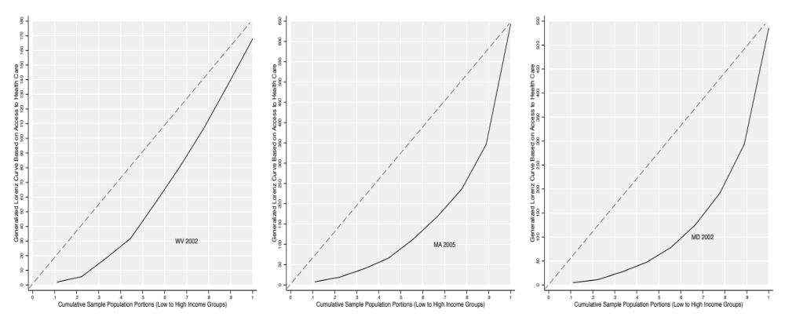

Low Inequality Moderate Inequality High Inequality

Figure 2. Descriptive Figures for the Dependent Variable: Weighted Gini-Coefficient of Income-Based Inequality in Health Insurance Coverage

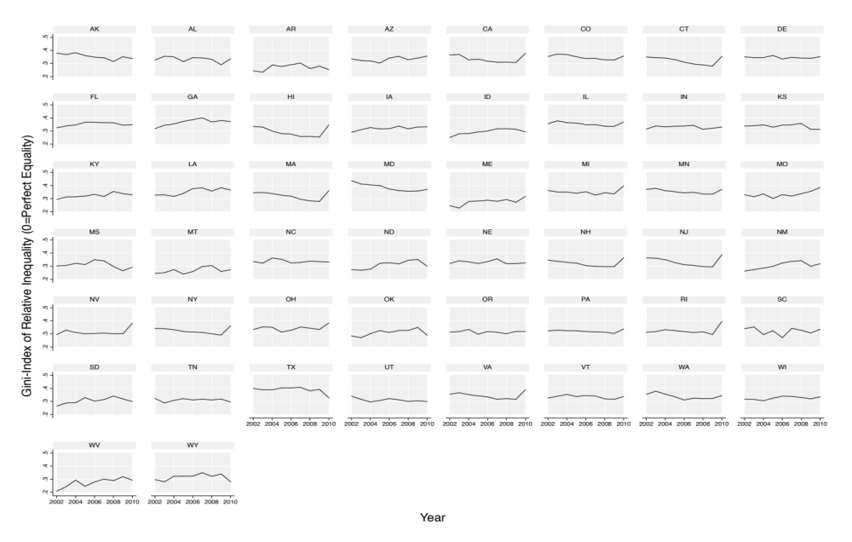

Figure 3. Evaluating the Linear and Non-Linear Effects of Income on Inequality

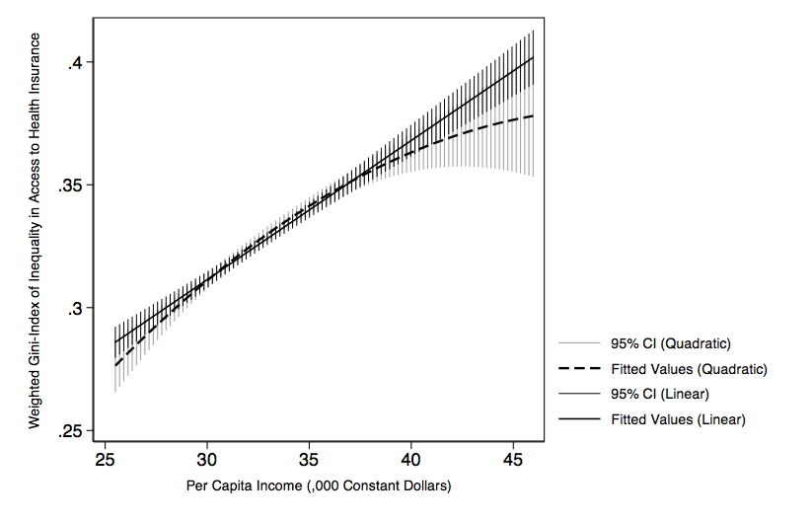

Figure 4. Evaluate the Linear and Non-Linear Effects of Education on Inequality

